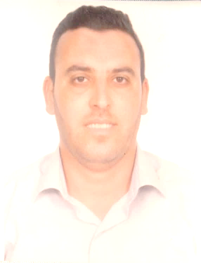

**Mr . Skander Chaaben**

*East Riffa . Kingdom of Bahrain .*

Email : [chaabane_skander@yahoo.fr](mailto:chaabane_skander@yahoo.fr) Mobile: +(973) 39545068

**Professional Summary**

Confident and capable sales expert with more than 6 years of experience in professional sales. A manager with the experience and skills necessary to oversee all customer interactions. Manage individual accounts and build relationships with clients. History of making sales and going on sales trips and perfectly comfortable interacting with potential clients. A candidate who combines a strong attention to detail with a high level of commitment, loyalty, and dedication.

**Skills**

-Extensive communication skills, both in sales, interpersonal, and management.

-Familiar building relationships, establishing lifelong connections.

-Intimately familiar with standard marketing techniques and experienced in improving sales of entire sales team.

**Work Experience**

**Sales Manager ( Sakly & Co company )**

**2014 to 2016**

* Lead entire sales team and ensure every member is meeting sales quotas for each month.
* Analyze all performance and identify areas that are inefficient; implement solutions to improve these areas.
* Compile sales information into one monthly report to be presented at quarterly meeting with the board of directors.
* Answer in-depth client questions and resolve issues the sales team members are unable to.
* Improved sales numbers by 15 percent over the course of two years.

**Account Manager**

**2011 to 2014**

* Oversaw all aspects of several client accounts, including all communication and interaction, placing orders, and making sales.
* Fulfilled requests on a daily basis to ensure client satisfaction at all times.
* Kept records of all sales information in efficient and concise sales reports.

**Sales Associate**

**2009 to 2011**

* Interacted with clients and used sales techniques to improve profits.
* Placed calls to potential new clients and communicated effectively to close sales.
* Performed administrative tasks to organize all accounts responsible for.

**Education**

Higher Institute of Languages

**Bachelor of English**

**2008**

**Republic of Tunisia**

**Hobbies and Interests**

I always make an effort to read and stay up to date with marketing magazines in order to remain informed on market trends. In my free time, I run and play soccer and basketball in order to stay active. I also volunteer my time when possible for biannual charity events.